**Problem 1:**

In the online game, you can buy a key to unlock a treasure box. You will then receive a treasure from the set {coin, sword, shield, potion, gun, grenade}, with equal probability, independent of other treasures. How many keys do you expect to buy before you get each possible treasure at least once?

**Solution 1:**

Define ‘’Success’’ as receiving a treasure that has not been received before.

Xi : number of keys spent between ith success and (i+1)th success

First key definitely get a distinctive treasure. So, X = 1 + $\sum_{i=1}^{5}{X_{i}}$. Then,

E[X] = 1 + $\sum_{i=1}^{5}{{E[X}_{i}]}$.

If receiving i different treasures so far, each key will give you another different treasure with probability (6-i)/6. Hence, we know Xi is geometric random variable with probability p = (6-i)/6

E[$X_{i}$] = 1 / p = $\frac{6}{(6-i)}$

E[X] = 1 + $\sum_{i=1}^{5}{{\frac{6}{(6-i)}}_{}}$ = 1 + $6\sum_{i=1}^{5}{\frac{1}{i}}$ = 14.698

**Problem 2:**

The demand for a certain weekly magazine at a newsstand is a random variable

with probability mass function p(i) = (10−i)/18, i = 4, 5, 6, 7. If the magazine sells for $a and costs $2a/3 to the owner, and the unsold magazines cannot be returned, how many magazines should be ordered every week to maximize the profit in the long run?

**Solution 2:**

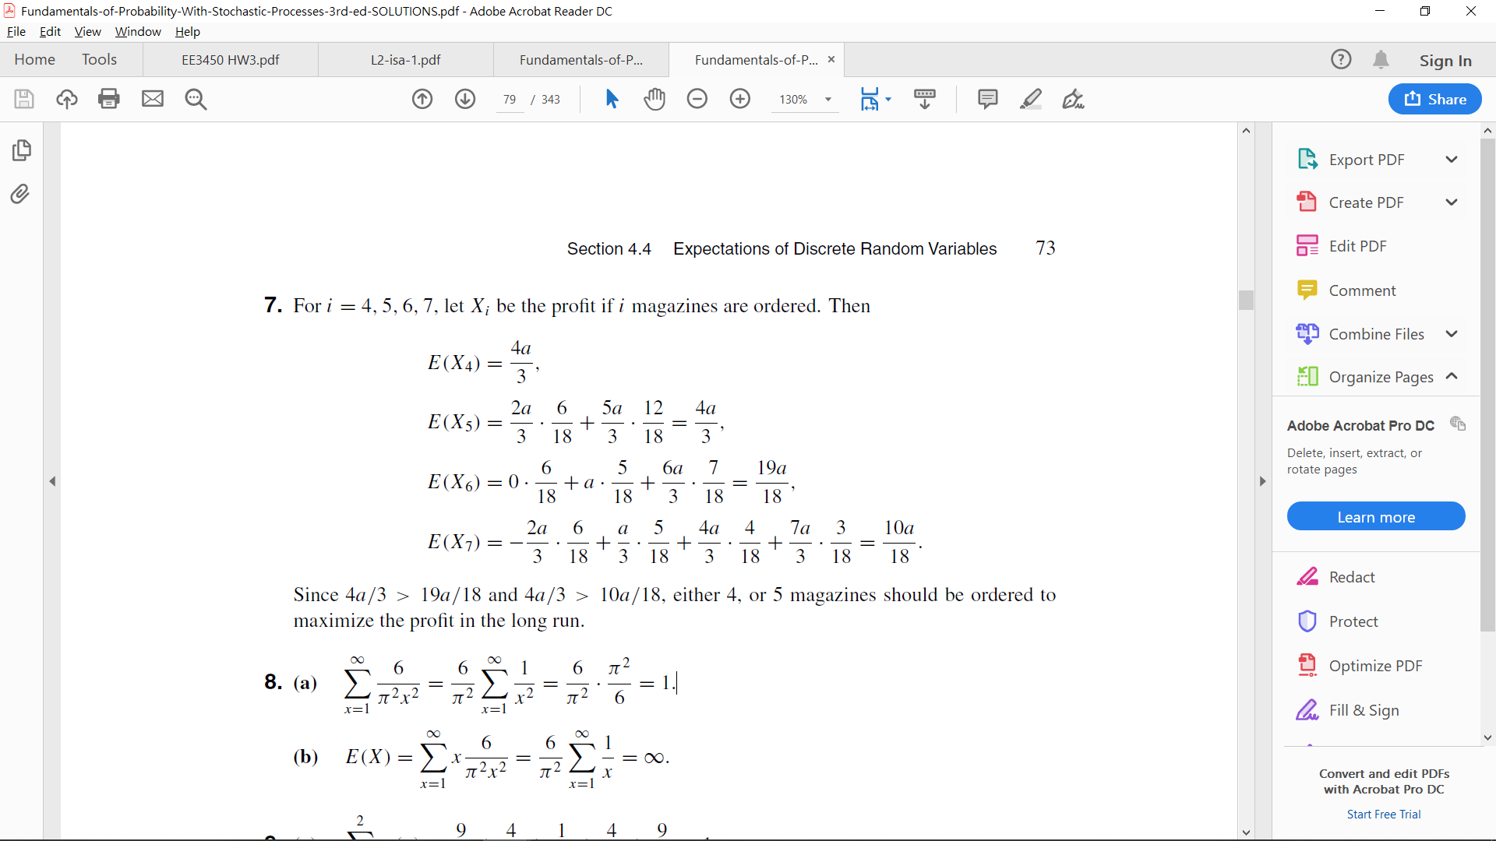

**Problem 3:**

A fair coin is tossed repeatedly and independently until two consecutive heads following by a tail (HHT occurred). find the expected value of the number of tosses.

**Solution 3:**

first note that the event could be separate into two part ：

1. tossed until two consecutive heads
2. after condition 1 , tossed until first tail

and the two part are independent (they don’t affect each other)

for example ： TTTHTHHT TTTHTHTHTHHHHT

so the random variable X(the number of tosses) =

Y(number of tosses until HH)+Z(number of tosses until T)

For Y：

use total expectation thm🡪 If A1…An are disjoint and partition of the sample space. E[Y]=P(A1)*E[Y|A1]+P(A2)*E[Y|A2]….and so on.

Now we divide sample space into 3 partition：

1.fisrt toss is T,we start again(with 1 waste toss)

2.First and second tosses is HT, we start again(with 2 waste toss)

3.First and second tosses is HH, we finish

So , we get E[Y]=P(first is T)E(Y|first is T)+P(first and second is HT )E[Y| first and second is HT]+P(first and second is HH)E[Y| first and second is HH]

That is, E[Y]=0.5*(E[Y]+1)+0.25*(E[Y]+2)+0.25*2 . solve it , then E[Y] is 6.

For Z：

It is just geometric distribution with p =0.5 , so E[Z] is 1/0.5=2.

conbine：

Now we have E[Y] and E[Z] , and X=Y+Z , so E[X]=E[Y]+E[Z]=6+2=8.

This is the answer.

**Problem 4:**

You just rented a large house and the realtor gave you 10 keys, original one and an extra duplicate one for each of the 5 doors of the house. Unfortunately, all keys look identical, so to open the front door, you try them at random. Find the PMF of the number of trials you will need to open the door, under the following alternative assumptions: after an unsuccessful trial, you mark the corresponding key, so that you never try it again.

**Solution 4:**

let X be the number of trials needed to open the door. Let Ki be the event that the ith key opens the door. So we have:

$$pX\left(1\right)= P\left(K_{1}\right)= \frac{2}{10}$$

$$pX(2) = P(K_{1}^{c} ) P(K_{2} | K_{1}^{c} ) = \frac{8}{10}·\frac{2}{9}=\frac{16}{90}$$

$$pX(3) = P(K_{1}^{c}) P(K_{2}^{c}|K_{1}^{c}) P(K_{3}|K_{2}^{c}∩K_{1}^{c}) = \frac{8}{10}·\frac{7}{9}·\frac{2}{8}=\frac{14}{90}$$

Proceeding similarly we see that

$$pX(k) =\frac{2(10 - k)}{90} for k = 1, 2, · · · , 10$$

**Question 5:**

A particular professor is known for his arbitrary grading policy. Each paper receives a grade from the set { A , A- , B+ , B , B- , C+ } , with equal probability, independent of other papers. How many papers do you expect to hand in before you receive each possible grade at least once ?

**Solution 5:**

After I get my first grade, the probability of me to get a different grade for next paper is $\frac{5}{6}$, which means the expectation value to get the second different grade equals to $\frac{6}{5}=1.2$. After getting the second different grade, the probability of me to get the third different grade for next paper is $\frac{4}{6}$ and the expectation value equals to $\frac{6}{4}=1.5$. Therefore the expectation values to get the forth , fifth, sixth different grade equal to $\frac{6}{3}=2 , \frac{6}{2}=\frac{3}{1} , \frac{6}{1}=6$ repectively , then the expectation value to get six different grade = $$E\left[X\right]=1+6\sum_{i=1}^{5}{1/i}=14.7$$